## 

horizontal line

**Data Analysis Through Zomato 500 Dataset Through Kaggle**

22-06-2022

Udyanshu Tiwari

# **Overview**

A zomato dataset of 500 orders from Bangalore City as a CSV File is taken and analyzed using Big Data Framework SparkScala.

# **Goals**

1. Analyzed Data should be sufficient for Restaurant Opening.
2. Analyzed Data should be sufficient for Restaurant Marketing.

# **Milestones**

1. Updating all average cost for two people by 100 after reading data from database

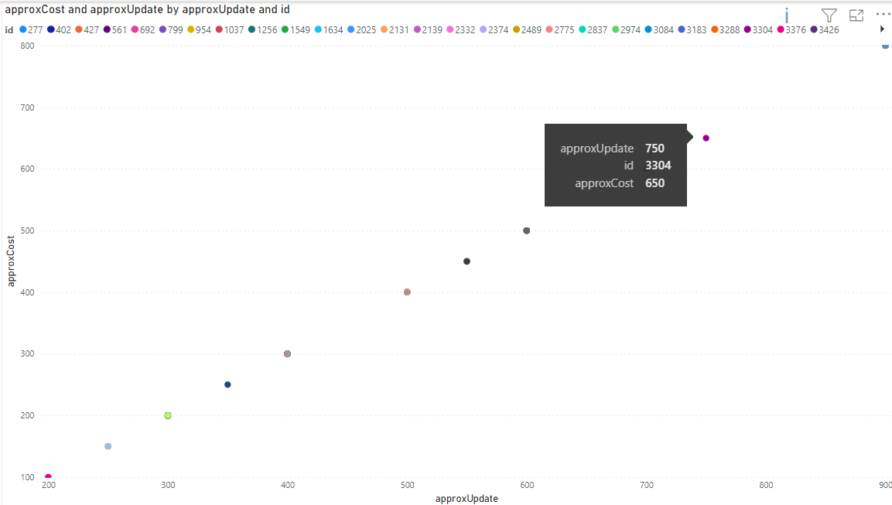

1. What are the cuisines mostly offered in restaurants?

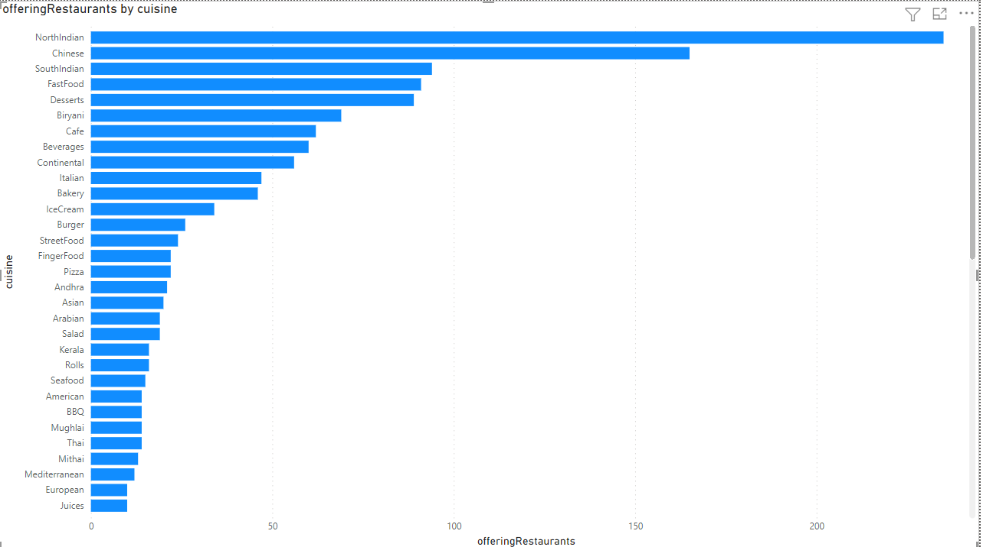

1. Restaurant which is most popular in terms of votes?

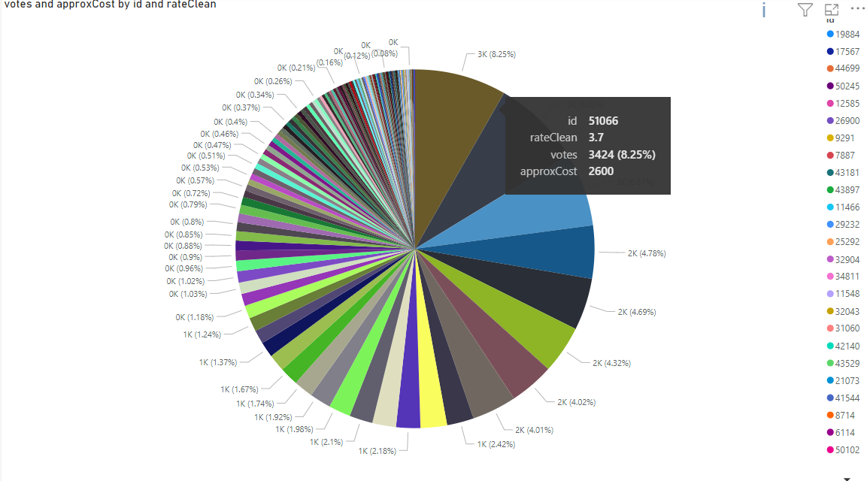

1. Which Cuisine is consumed Mainly By People and on which price range?

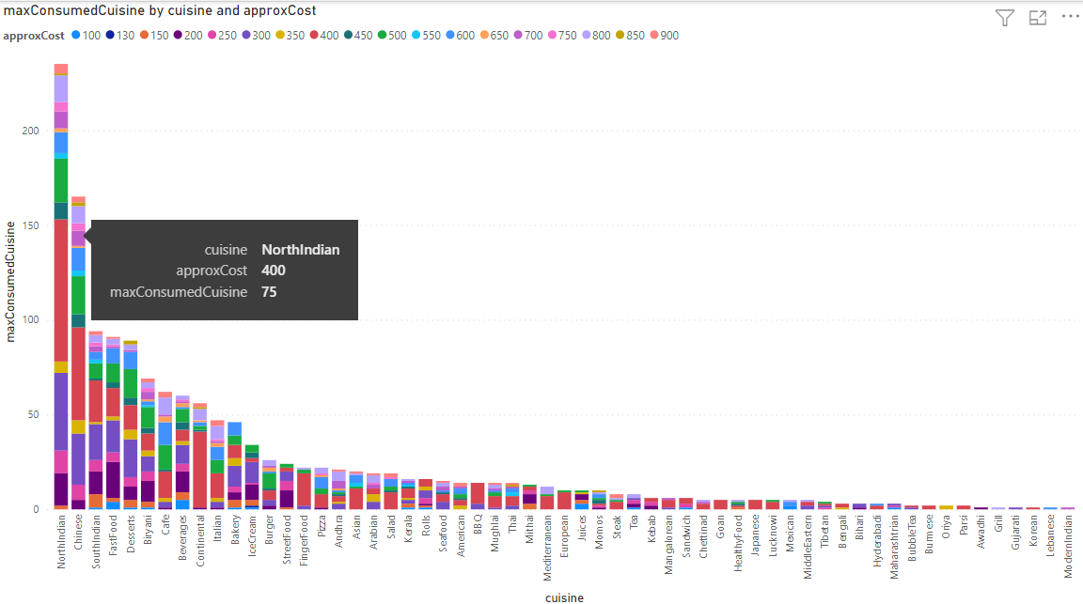

1. Which type(restType) of cuisine is offered by most restaurants?

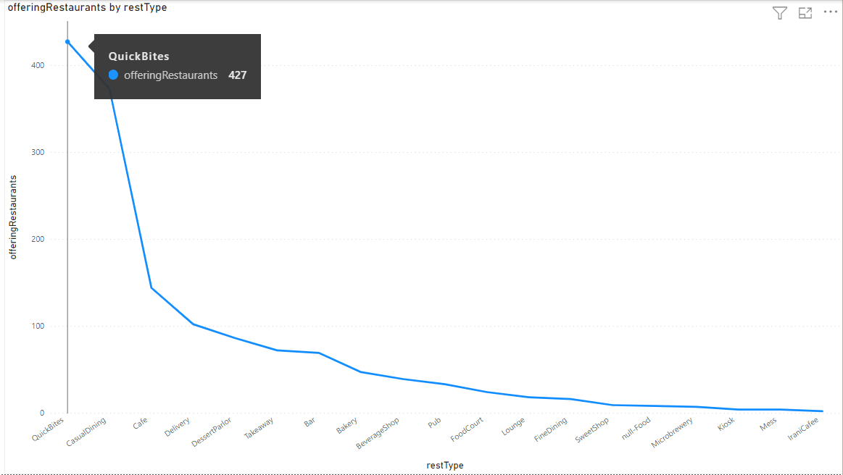

1. Which area offers the most online deliveries?

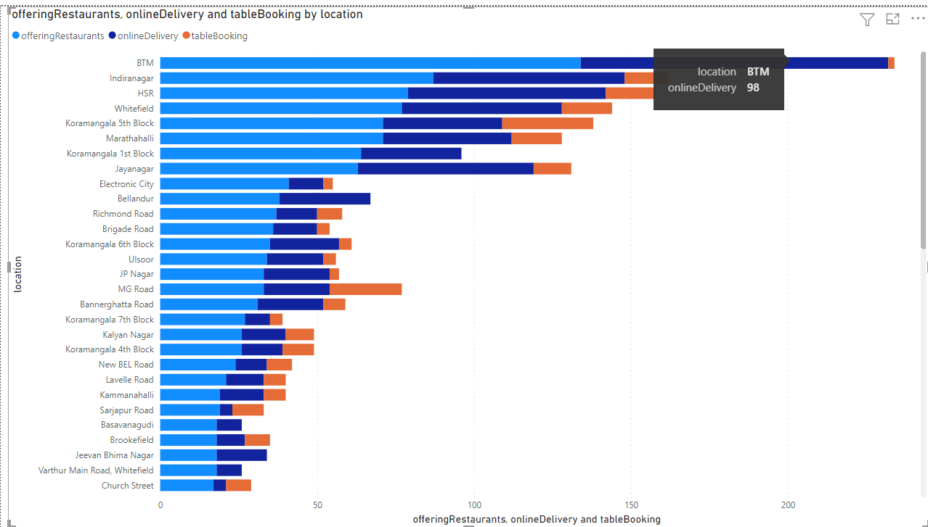

1. What is the rating of restaurants that make the most consumption of cuisine ‘North Indian’?

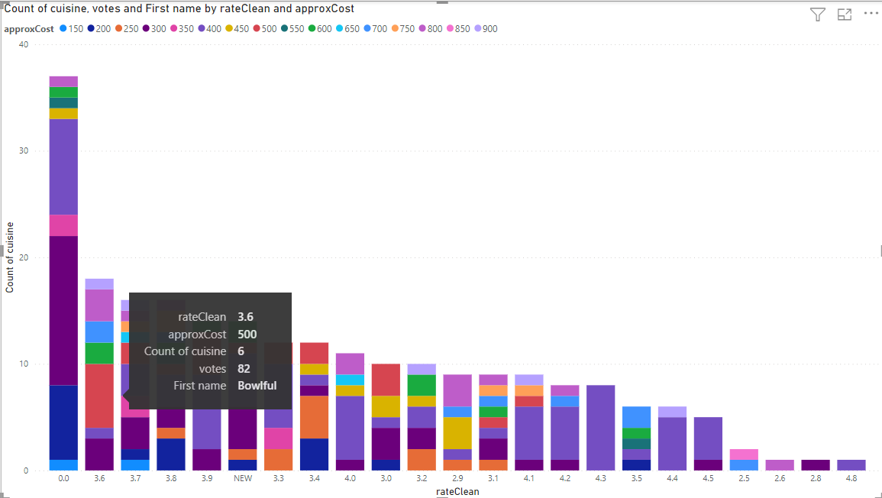

1. Which restaurant sells North Indian costly and still making business?

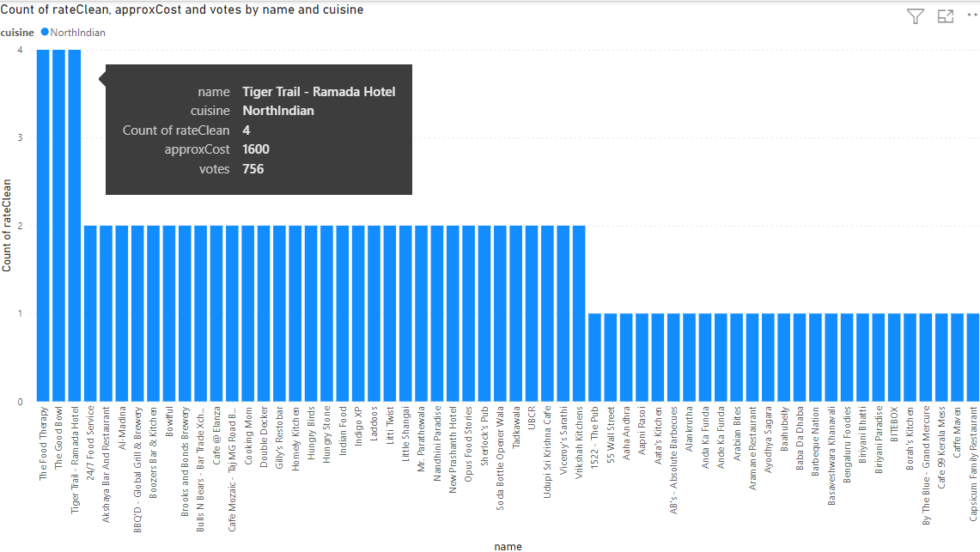

1. Which Restaurant offers the most rated and voted cuisine?

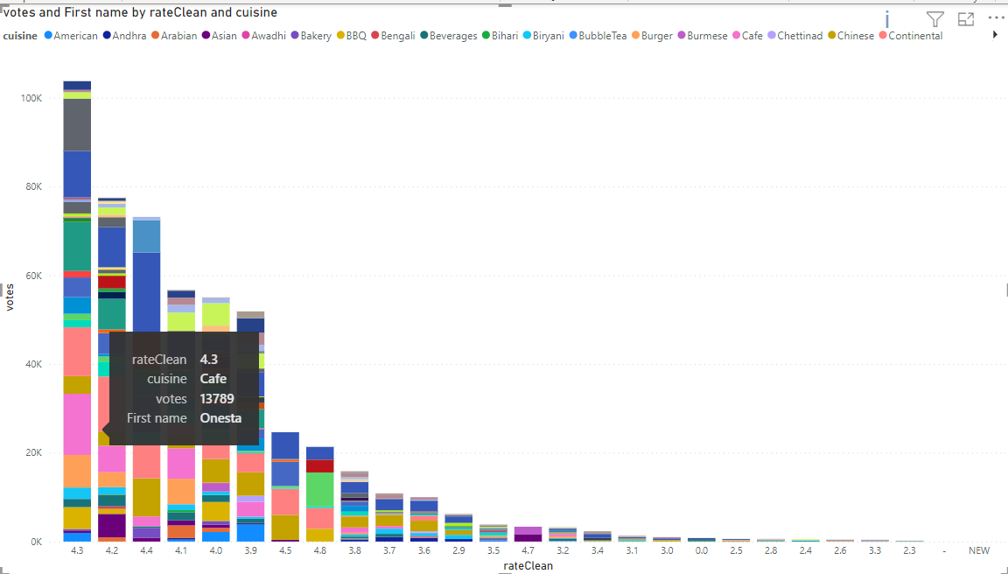

1. Which location has the highest number of restaurants?

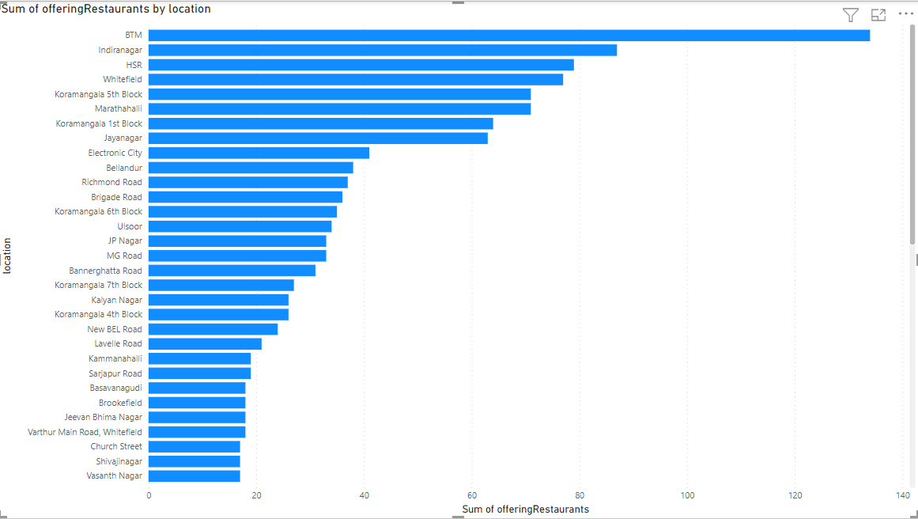

1. Which location serves mostly on table booking?

## 

1. Which restaurant has costly cuisine yet voted highest and consumed?

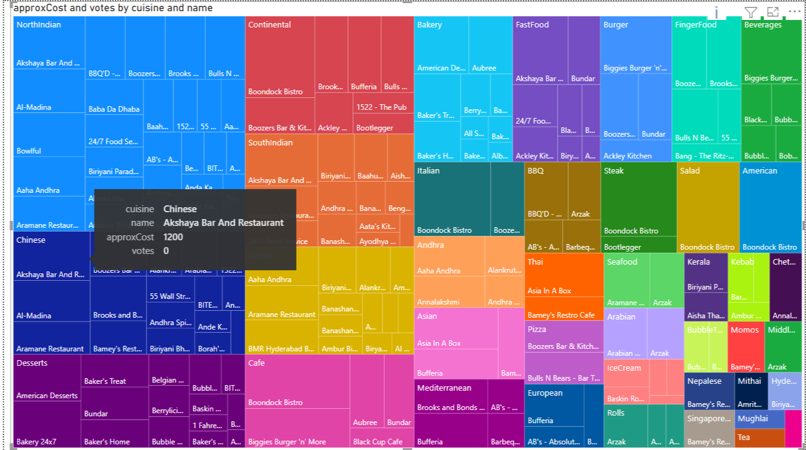

1. Which restaurant has a costly rest type(Food Court) yet voted highest and consumed?

## 

## 

1. Which cuisine is most popular in terms of votes?

## 

1. Which restaurant has maximum votes for Rest Type ‘FoodCourt’ ?

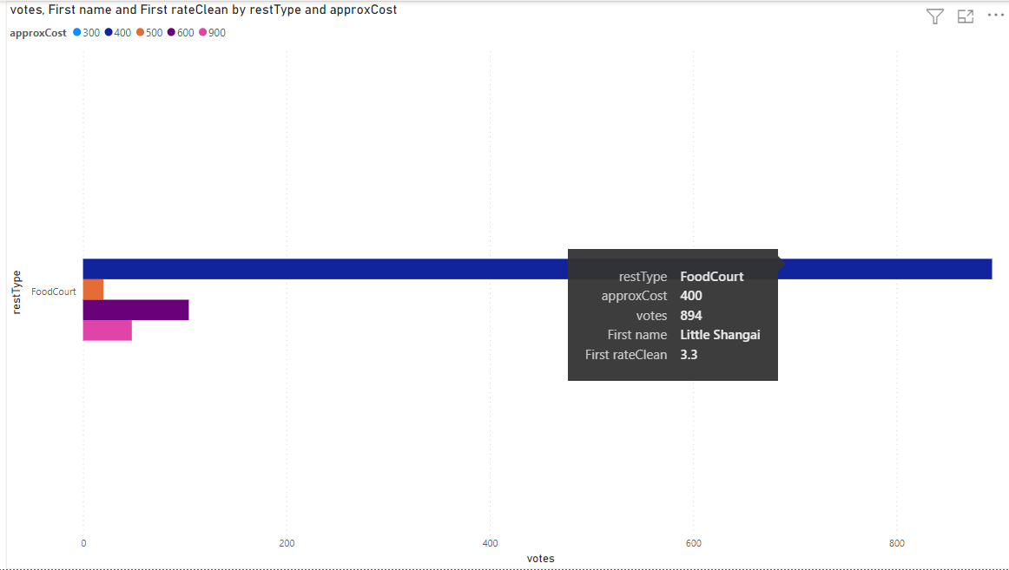

1. Restaurant offering Minimum approx cost for North Indian Cuisine ?

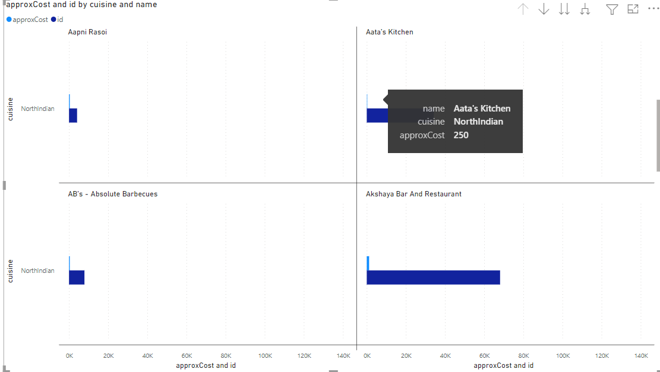

1. Restaurant offering Minimum approx cost for FoodCourt Rest Type?

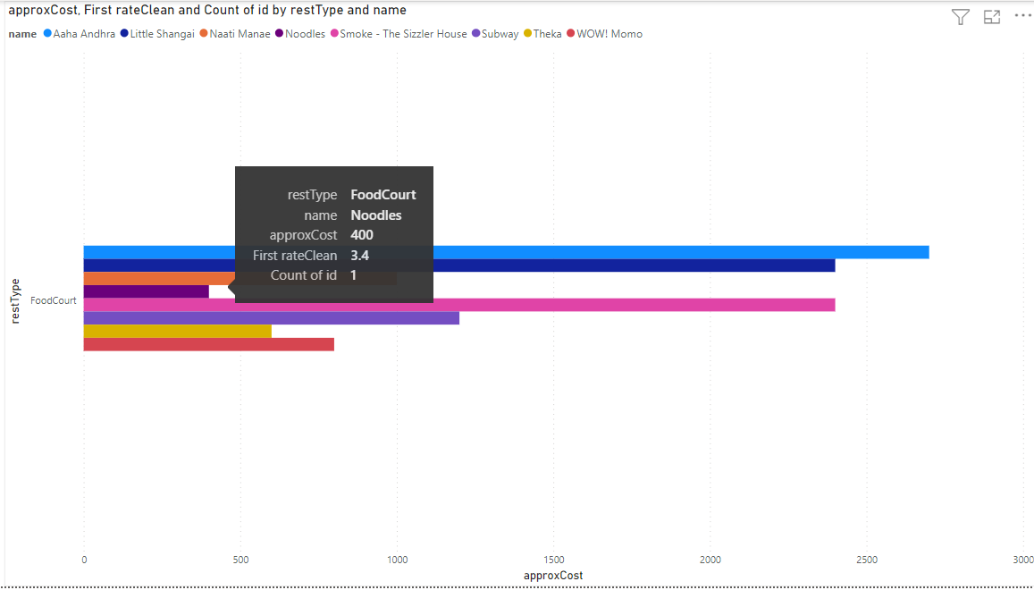

1. Restaurant making Business with null rating?

## 

1. Restaurant wise Hierarchy for votes in terms of Restaurants for proper cuisine (most voted cuisine with minimum rating)?

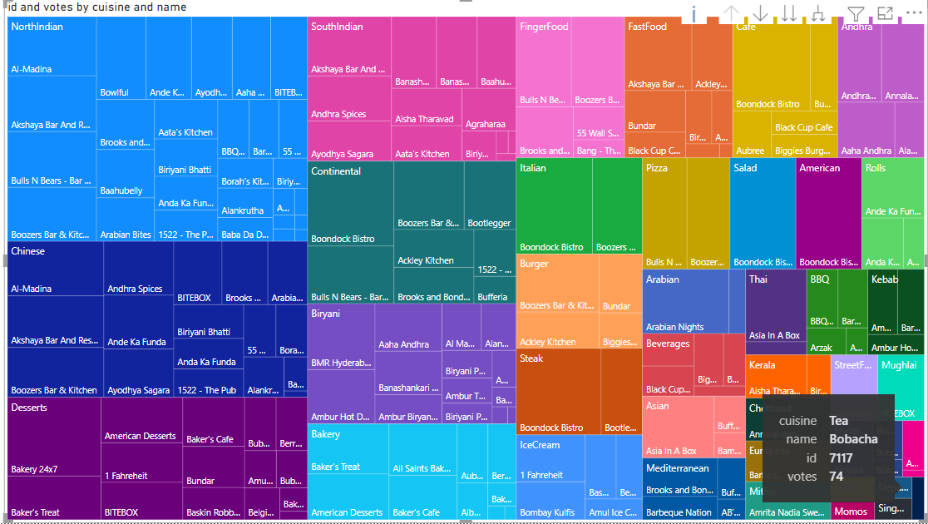

1. What are non offering online delivery locations?

## 

1. Which restTypes are mostly offered in how many restaurants?

